**Networking Overview**  
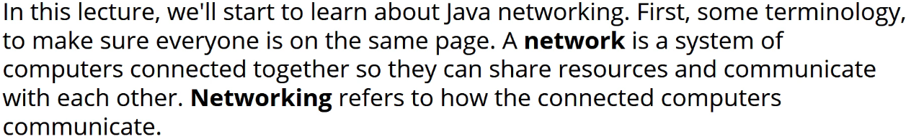

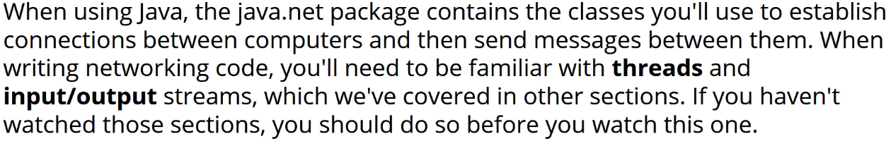

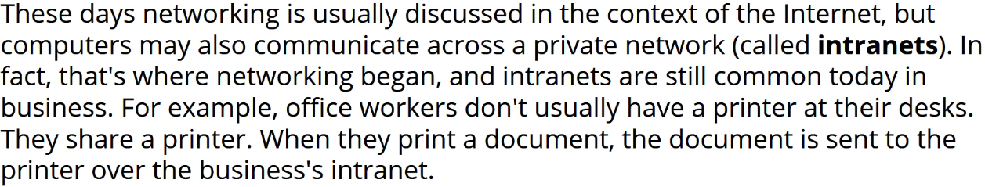

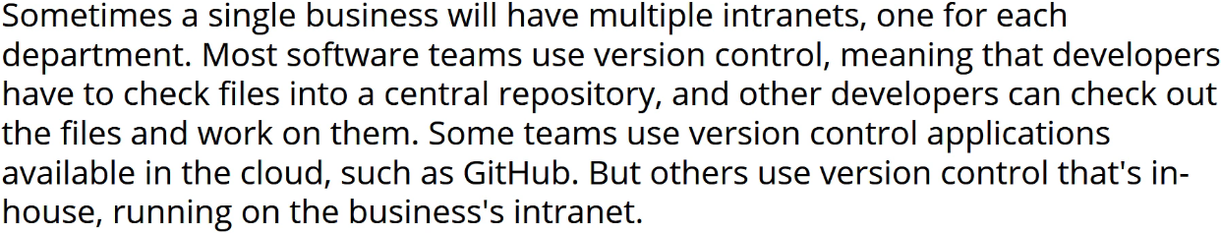

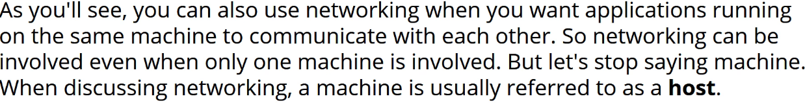

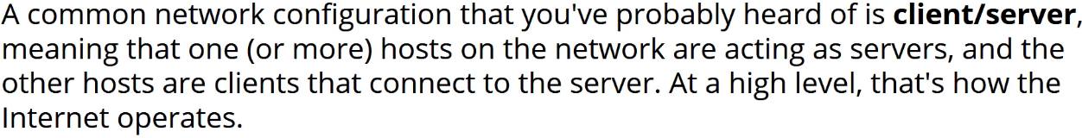



* MySQL database comes with software called workbench that you can use to perform database operations. So the workbench is the client and it connects to the MySQL database server on that local host. And of course, it could also connect remotely to another server if needed as well.

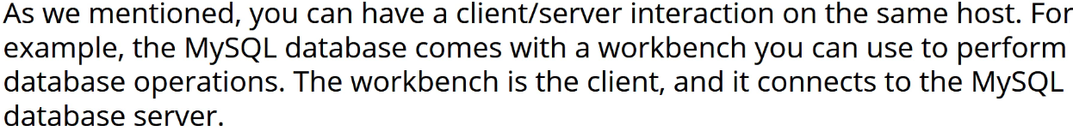





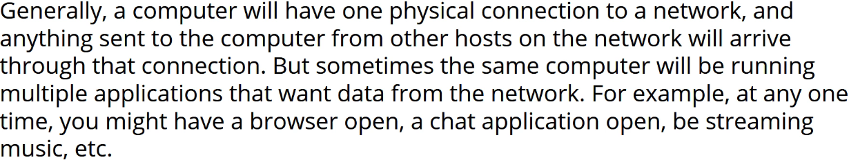

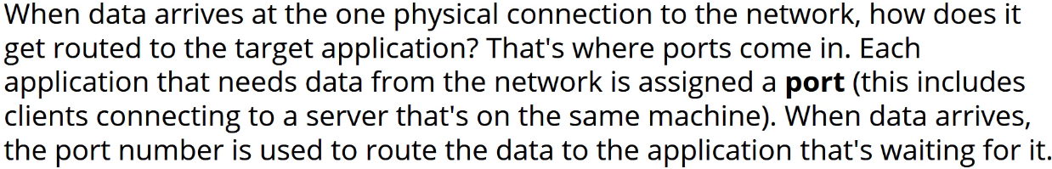  
* Every **HOST** connected to the Internet has a unique **IP Address**, including yours.  
=> **To find out what your IP address is**, you can run a command from your operating system’s command line but it’s also often just as easy just to do a **search for “what is my IP” in browser**.

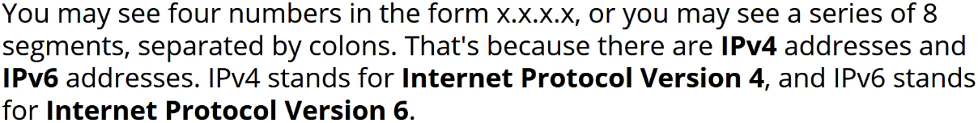

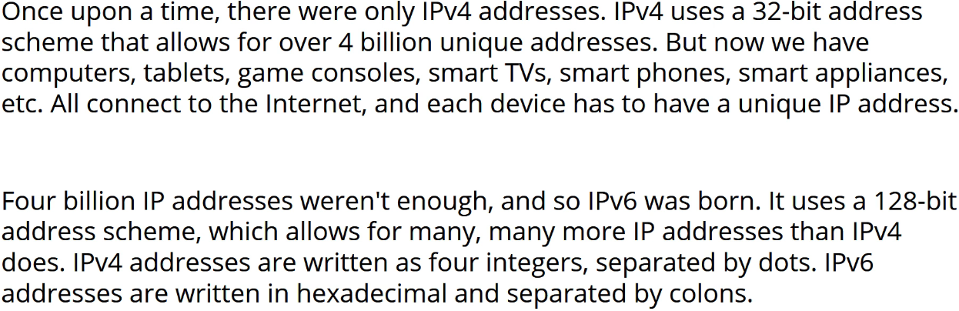

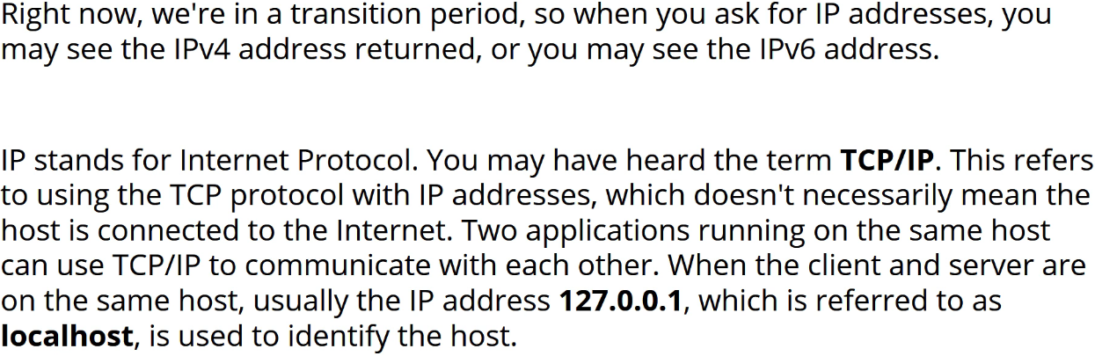

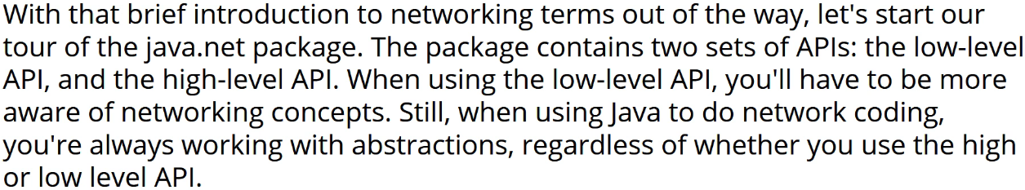

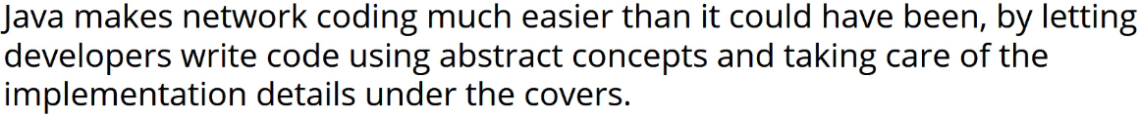



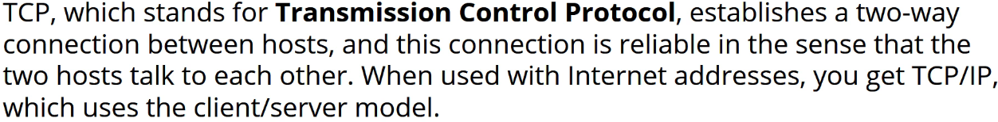

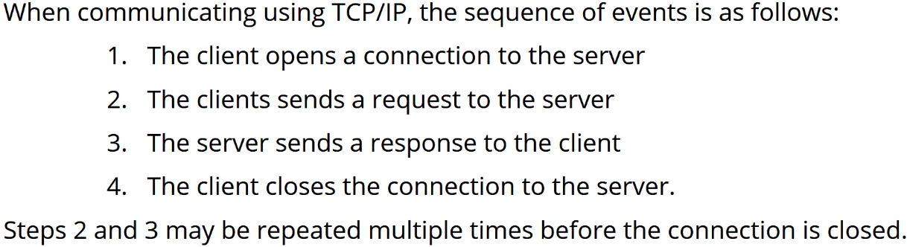

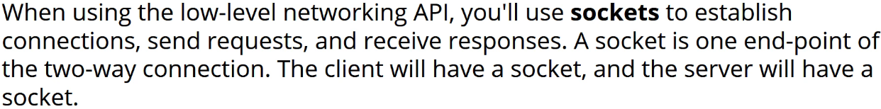



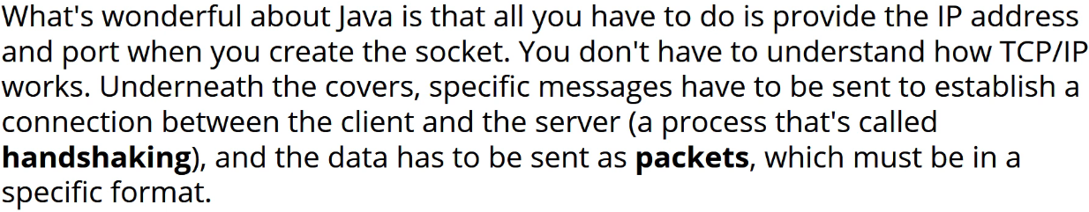





**First Client and Server Apps**  
* First project will be called EchoServer and we’re going to start working on the server application. Its purpose is just going to be to echo back to the client whatever text the client sends it.  
**ServerSocket**  
* The PORT can be an integer between 0 and 65 535 inclusive.  
* Some port numbers are already reserved or may already be used by other applications.  
* They way to find out is to assign a port number and see if the socket instance is successfully created.  
* We want the server to listen for clients on the port that we’ve assigned.  
**ServerSocket accept()** => returns a Socket instance. Note that’s a Socket instance and not a ServerSocket. This will be the Socket used to communicate with the client.  
* Keep in mind that every client that connects to a server will do so using the same port but through its own Socket.  
* **The accept() method is going to block until a client connects to the server**.

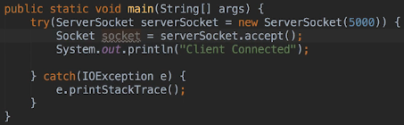  
* When a client does connect, the server will use Input and Output Streams to send data to the client and receive data from the client.  
**Socket getInputStream()** => returns the InputStream associated with the ServerSocket instance.  
**Socket getOutputStream()** => returns the OutputStream associated with the ServerSocket instance.  
**BufferedReader  
InputStreamReader  
PrintWriter** => **the 2nd parameter specifies whether you want to automatically flush the OutputStream that the PrintWriter is using**. If you don’t specify true, then you’ll have to call the **flush()** method after every write to the Stream to ensure the data is actually sent.  
* A common practice is to wrap the InputStream with a BufferedReader and to wrap the OutputStream with the PrintWriter.  
* You want the server ot remain alive until the client doesn’t need it anymore, so this is one time where you will actually intentionally use an Infinite Loop.  
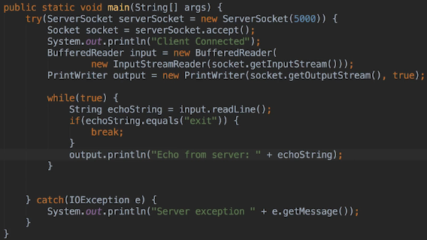  
* We’re writing the string to the socket using the PrintWriter println() method.  
* Now let’s create the client application, we’ll call the project EchoClient.  
* It’s going to start the same way, except we’re going to create a Socket, not a ServerSocket.  
**Socket** => we need 2 paramaters:   
 1) Address of the HOST we want to connect to  
 2) The PORT number  
* If “localhost” doesn’t work, you can try passing the IP address: 127.0.0.1 which is an IP address that resolves to this computer as well. The “localhost” is actually an alias for the computer’s IP address.  
* We’re using a DO WHILE loop because we want the loop to execute at least once.  
* We’re using the stringToEcho - the PrintWriter - to send the string to the server.  
* We’re using the echoes - the BufferedReader - to read the data coming back from the server.  
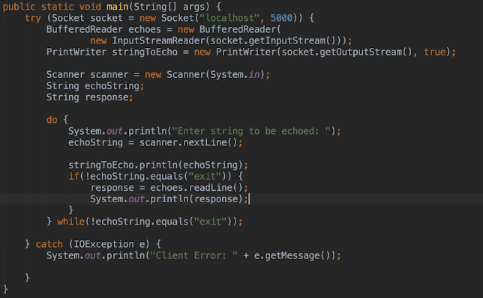  
* Let’s run the server application and when we run the client application, we see the “Client Connected” message in the server application console. So the accept() method is no longer blocked. And it’s waiting for the readLine() input to get something.  
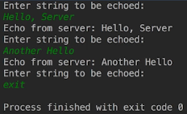 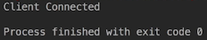  
* The server we’ve written can only connect to 1 client.  
* Next, we’re going to start modifying it so that we can accept connections from multiple clients.

**Multi Threaded Server**  
* We’re going to move the socket code to the WHILE loop.  
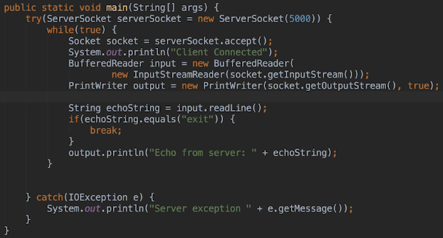  
* Now we can have multiple clients connecting to our server.  


* The server code has problems:   
**=>** If we close the clients from right to left, the server doesn’t close down.  
* In a real-world situation, that wouldn’t be a problem because usually you want the server to be running 24/7 but if you ever wanted to bring down or terminate the server, you’d then do so manually in that scenario. So we can just close it down manually in IntelliJ.  
**=>** If we run the client but don’t type anything and run another client, we see only the first “Client Connected” message. Because we didn’t type anything in the first client, the server code is actually **blocked, waiting for input - at the input.readLine()**. So basically the first iteration of the loop hasn’t completed, so the server hasn’t called accept() again. If we type something in the first client now, then it continues and we see the second “Client Connected” message.  
**=>** Each client will only ever see 1 message echoed back to it. If we type another message, we don’t get the response back. That’s because the server’s now blocked on the accept() call.  
* We’re going to make a change to the server code to simulate a long-running task. Because we need time to switch to a second client and type something into its console, we’re going to have the server sleep for 30 seconds every time it receives input from the client.  
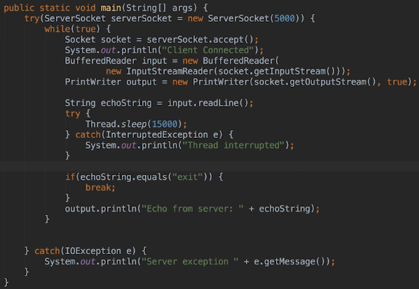  
* What’s actually the cause of all these problems?  
=> **Because the server is doing everything on a single Thread**.  
=> **Servers that can connect to multiple clients will run multiple Threads**.  
=> We’re going to **update the code so that the server handles each client on a separate Thread**.  
* This is going to do 2 things:  
1) => **It’s going to let the server be more responsive to client connection requests**.  
2) => **It’s going to prevent one client from holding the server for too long a period**.  
* On the server’s main thread we’re going to call the accept() method. But whenever it accepts a connection, what we’re going to do is kick off a new Thread for the client and then call the accept() method again. So each client thread will be responsible for creating the Input/Output streams, listening for requests on the client, and then responding to those events.  
* Let’s create a new class: Echoer that extends Thread. And we’re going to add the run() method and that’s going to be called when the thread is started.  
* We’re not going to use a TRY-with-resources statement because the method doesn’t create the socket when the server connects to a client. So we have to explicitly close the socket when we’re finished with it.

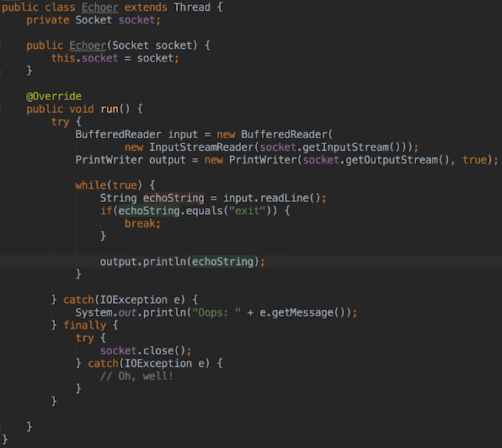  
* Now back in our Main.java:  
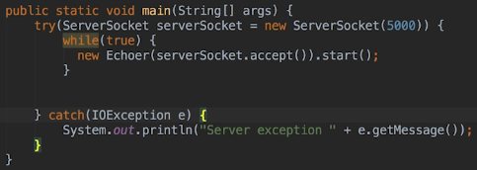  
* Basically now we’re creating the ServerSocket as before and still writing an infinite loop, but this time we’re kicking off a new Thread every time we accept() a connection.  
* And recall that the accept() method returns a Socket for the client and that’s what the serverSocket.accept() does and we’re returning/sending that to the Echoer in the constructor and then calling the start() method.  
* So I guess we could’ve changed the code to this instead:  
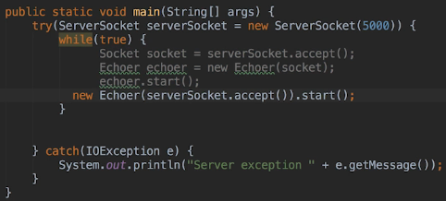  
* **The commented code is equivalent code**.

**Multi-Threading and Timeouts**  
* If we run it, we can see that everything is working correctly.  
* Now let’s sleep each thread for 15 seconds before printing the string.  
* And so that we can see that there’s no delay for client connections, we’re also going to add a println statement to the run() method itself.  
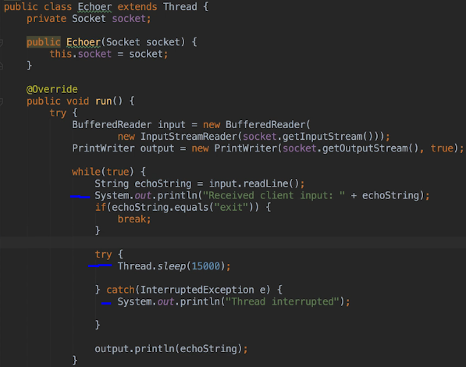  
=> The point here is that 1 Thread taking a while will not result in every client being blocked until the long-running client is finished, which is pretty cool.  
=> Now you can see why the server doesn’t terminate automatically - just because 1 client wants out, doesn’t mean they all do and even if all the clients exit, other clients may want to connect in the future, and therefore the server remains alive and listening for that reason.  
* **Note though, that when a client does send exit, the Thread for that client terminates, the socket.close() is called**.  
* Alright, that’s the basics of working with sockets.  
* Before we move on to UDP, I want to discuss Timeouts, briefly.  
* When a client is communicating with a server, it doesn’t want to block forever. If it server’s gone down, or it isn’t sending a response for some other reason, then the client will want to report back to the user, otherwise the user is going to think the application is frozen or just died for some reason.  
=> We can set a Timeout period on a Socket. The idea here is that if a socket doesn’t respond within the timeout, then we get a **java.net.SocketTimeoutException** thrown.   
**Socket** **setSoTimeout()**  
* We’ll need to handle the SocketTimeoutException, in this case we’re going to terminate the application but in a real world, it would depend on the situation. So you might want to for example try sending the request again, you might want to abort that particular action and inform the user. Or perhaps you just want to terminate the application. You might want to get the user a choice.   
* We’re going to add a CATCH block to the existing TRY block and we’re going to catch the exception outside the loop and then terminate the client application.  
  
  
  
  
  
  
* In EchoClient:  
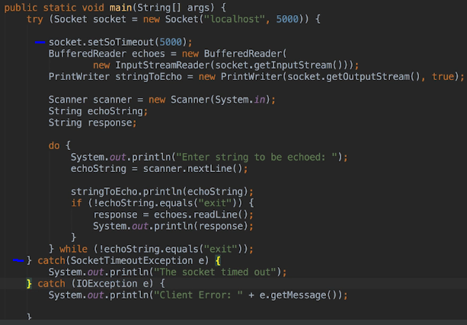  
* The timeout is 5 seconds and the sleep is 15 seconds, so the socket should time out.  
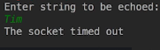  
* The client also terminated.  
* So using timeouts is a very important tool and it prevents a client from blocking forever.  
* That’s all for TCP/IP.  
* Next, we’re going to start taking a look at another protocol, UDP - User Datagram Protocol.

**UDP Server and Client**  
* **UDP - User Datagram Protocol**  
* When using TCP, some handshaking has to take place between the server and the client. In other words, the client has to connect to the server and the server has to accept that connection.  
* So the client sends a request and the server sends a response.  
* So it’s a two-way connection and there’s tight coupling between the client and the server.  
* The TCP also performs error checking and will resend messages that don’t make it to the server.  
* So it’s quite a reliable protocol, but that reliability requires overhead which can ultimately affect performance.  
=> When using UDP, there’s no handshaking at all. And the destination host, which may or may not be a server, doesn’t actually send any responses to the message sender.  
=> So you use it when you don’t need a reliable connection or a two-way connection or when speed is essential.  
=> **If you require a response to a message you send over the network, then you wouldn’t use UDP**.  
=> UDP uses Datagrams.  
=> Datagram is a self-contained message and it’s not guaranteed to arrive at its destination.  
=> **UDP is often used for time-sensitive communication and when losing the odd message or packet here or there won’t matter**.  
=> **For example VOIP - Voice Over IP applications like Skype and Video Streaming usually use UDP because speed is more important than ensuring that absolutely every packet arrives**. Our eyes won’t notice if the occasional package isn’t received, for example when we’re watching a video. Also, the data arriving at the client is immediatelly replaced by more data so it’s not critical that all the messages reach the client.

=> Data can be sent much more quickly using UDP.  
* Let’s create a client and a server that use UDP. We’re going to start fresh and we’re not going to worry about using Threads this time since you now know how to do that from the TCP kind that we worked on.  
* For this demo I just want to show how to send data using a Datagram.  
* In a real-world application you would definitely want to use Threads.  
**DatagramSocket  
byte[]  
DatagramPacket  
DatagramSocket receive()**  
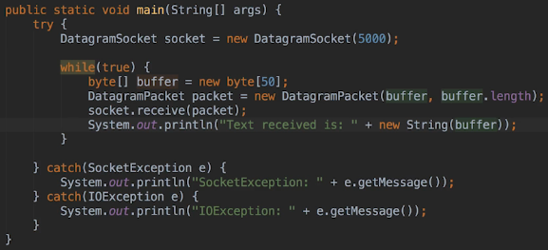  
* **socket.receive(packet) fills that packet with the content**. And this method actually blocks until data is received. Once the data has arrived, the buffer you pass to the DatagramPacket constructor will contain the data and we’re then printing that to the console.  
* It’s important to note that the receive() method doesn’t create an end-to-end connection between the server and the client so it doesn’t return anything the server can use to send data back to the client.  
* When using TCP, the accept() method did create an end-to-end connection so it returned a Socket the server could use to communicate with the client but that’s not the case here for UDP.  
* Let’s now code the client.  
**InetAddress**  
**InetAddress.getLocalHost()**  
**String** **getBytes()**  
**DatagramSocket** **send()**  
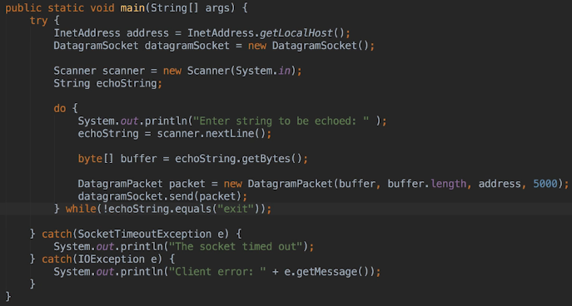  
* There’s also:  
**InetAddress** **getByName()** => lets you pass a host name to it, returns the InetAddress of the host.

* You would use the getByName() if you were running the server on a different machine.  
* Recall that I said the Datagram is a self-contained message - you can see it here - the message contains not only the data but also the address and the port number.  
* So if the server wants to respond, it can get all the information it needs from the DatagramPacket.  
* In the TCP case, once the end-to-end connection was established, the Socket had all the information required to communicate with the client. So the server didn’t have to get the information from each message.  
  
* At the moment we’re seeing the complete buffer so we’ve got all these null characters.  
* If we wanted to only output the information related to the number of characters received, the actualy message, we can change this by creating a new string buffer to only return the actual amounts.  
* In Server file:  
**DatagramPacket** **getLength()**  
  
* Alright, now before moving on to the High Level API, let’s see how the server would get the information it needs from a packet to be able to send data back to the client.  
**DatagramPacket getAddress()**  
**DatagramPacket getPort()**  
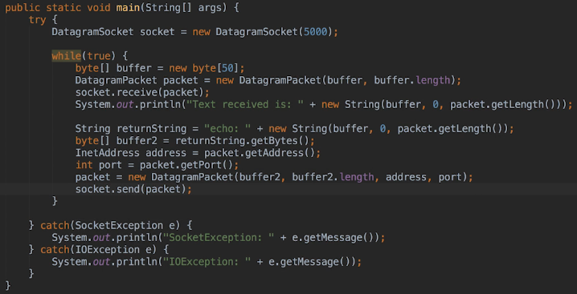  
* So, once the server has received a packet, it uses the address and port in the received packet to create a new DatagramPacket which it then sends back to the client.  
* We could’ve used the same byte [] for both input and output but we’re using 2 different ones here for clarity.  
* The code gets the InetAddress and the port from the packet it received, and that’s because there’s no permanent end-to-end connection between the server and the client.  
=> In fact, UDP is often referred to as a **Connectionless Protocol** for that reason.  
* Keep in mind that when using UDP, you often don’t want a response. We’re setting up the client at the moment to wait for a response purely for demonstration purposes. But again, you wouldn’t necessarily do that in a real-world application.

* In Client file:  
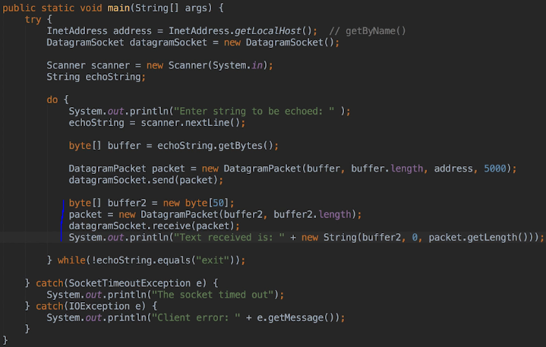  
* We’re storing the data coming back to us, we’re creating a packet based on that byte array so it can be used to receive the data. Then we receive() the data and output it. The receive() blocks so it sits there and waits until it receives/gets the server’s message.  
* So that’s UDP.  
* We’ve now finished looking at the **Low Level API**.  
* And you can see that even though it’s quite low level, we’re still working with Abstractions here.  
* **All the complexity of handshaking and constructing packets is largely taken care of by Java**.  
* So you’re free to focus on the data you want to send.  
* But as you’ll start seeing in the next video, the High Level API hides even more of these details from you.

**High Level APIs**  
* In the last few videos, we looked at the Low Level Networking API, which involves PORTs and SOCKETs.  
* While it’s important to understand the Low Level Concepts, most modern applications are mainly interested in accessing the internet, and we’ll use the High Level API to do so.  
* **Using the High Level API, you don’t actually even need to know about PORTs and SOCKETs**.  
=> Instead, you’ll use URIs and URLs.  
**URI** => **Universal Resource Identifier**  
**URL** => **Universal Resource Locator**  
* What is the difference between a URI and URL?  
* It’s not necessarily that easy to answer this question.  
* **W3C is the World Wide Web Consortium - responsible for Web Standards**.  
<https://www.w3.org/TR/uri-clarification/>  
* This entire page is trying to explain the difference between a URI and URL.  
* RFC = Request for Comments - it’s a formal document from the Internet Engineering Task Force - IETF.

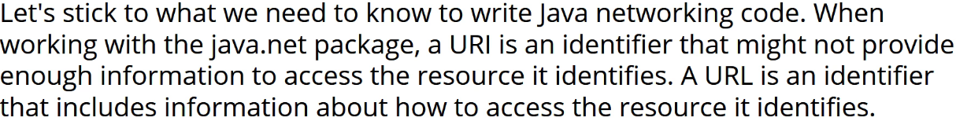



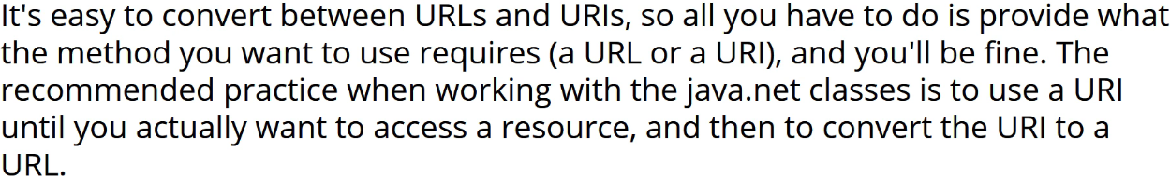



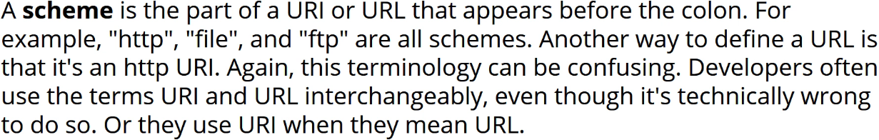

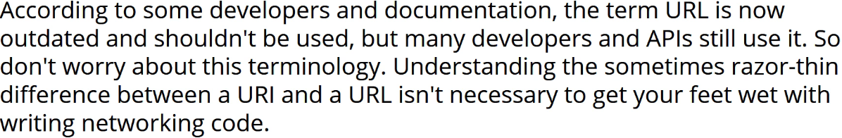



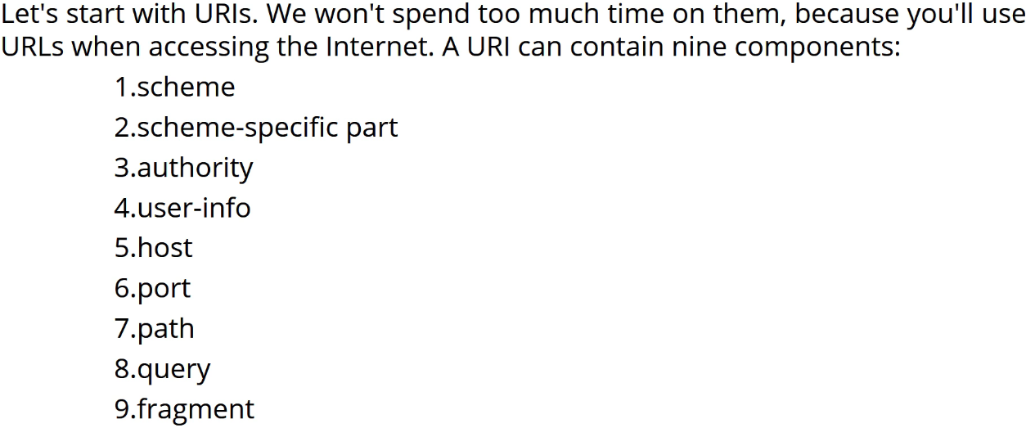

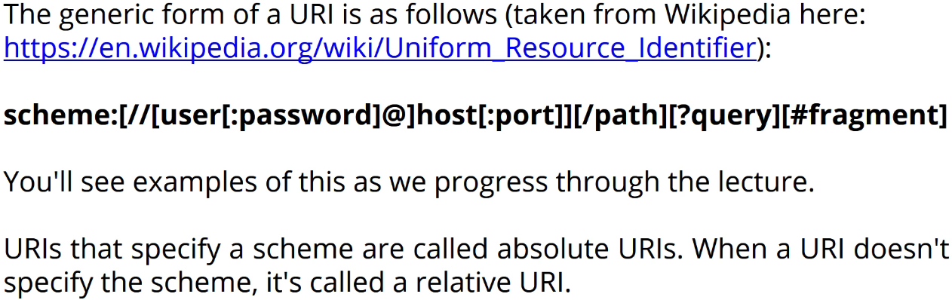

* Let’s now start creating some code.  
**URI**  
**URISyntaxException**  
**URI getScheme() => before the colon :  
URI getSchemeSpecificPart() => everything after the colon : before the #, this is the identifier for the resource that you want to use  
URI getAuthority() => the host and optionally a password as well as the username and port number, the host can be a registered name as in this example, or an IPv4 / IPv6 address  
URI getUserInfo() => the username and password, basically any credentials required to access the resource  
URI getHost() => the host name or an IPv4 or IPv6 address  
URI getPort() => the port number  
URI getPath() => the path to the resource on the host  
URI getQuery() => always separated from the part that comes before it by a ?, the syntax can actually be in any format because the standard doesn’t strictly define it, but it’s often a set of key value pairs  
URI getFragment() => specifies the secondary resource or location**  
* In the code here, we’ve created a URI instance for a URL that will form a database query.

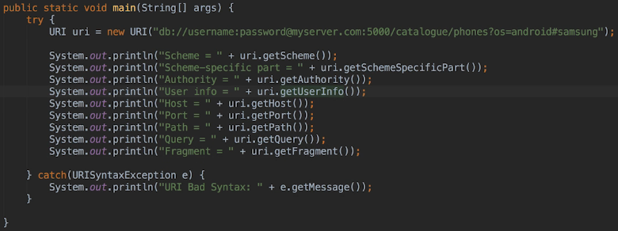  
  
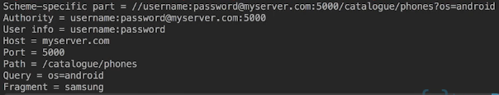  
* **You can write your own schemes, although you’re encouraged not to do so to avoid name conflicts**.  
* **Though usually when you want to define your own scheme, there’s alternate ways to accomplish what you’re trying to do. Using namespaces is one example for that**.   
* In this case the resource is a database and the path in getPath() points to a specific table within the database.  
* In this case the fragment in getFragment() says that only samsung phones should be returned. If the URI pointed to a webpage, the fragment could be an ID for a section heading for example, in the HTML itself.  
* As you may have noticed, there’s an overlap between the contents of some of these components.  
* And also many of the components are optional.

* If we change the URI to:  
  
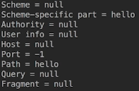  
* It’s still a well-formed URI.  
* It doesn’t exist but that’s actually fine because just as with files, until you actually try to access a resource, it doesn’t have to exist.  
* And remember that you will use a URL rather than a URI when you actually access a resource.  
* The only other thing that I’m going to touch on for URIs is how to convert them to URLs.  
**URL**  
**URI** **toURL()**  
**MalformedURLException**  
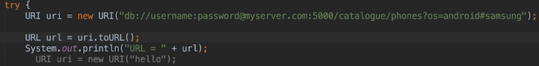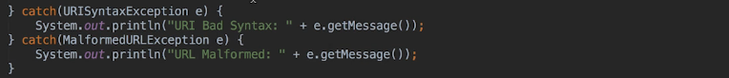  
* If we run it, we get:  
  
=> That demonstrates that the URI doesn’t have to be valid to work with it. It only has to be valid when you wanna convert it to an absolute location, as we’re trying to do here by converting it to a URL.  
* Let’s change the URI to:  
  
* When we run it, we get:  
  
* The URL is now equal to the URI because the URI is an absolute path - **Absolute URI**.  
* Let’s take a look at a **Relative URI**. It doesn’t completely identify the resource.  
  
=> It doesn’t contain the schema, so you don’t know if the URI points to a webpage or a database or a file or something else.  
=> It doesn’t contain the root location, so if this was a webpage, the URI doesn’t contain the server or any credentials required to access the location.  
=> It also doesn’t specify database table or a disc driver location.  
* So in other words, there isn’t enough information here to really access the resource.  
* If we run it, we get:  
**IllegalArgumentException**  
  
* **URIs can be Relative, but URLs have to be absolute, so the expcetion makes sense here**.  
* So you can’t get an absolute URL from a relative URI because there’s not enough information in the URI to determine the absolute location of the resource.  
* When you want to access a resource, you will use a URL.  
* At that point the location of the resource has to be absolute, otherwise the Java Runtime won’t have enough information ultimately to access it.  
* **There will be times when you want to use relative URIs though, but usually you’ll use them along with a base URI**.  
=> **This base URI will specify the root of the relative path which can be quite handy**.  
* **If you’re accessing lots of pages on a website, then instead of working wiwth absolute URIs, it’s probabaly better to have a base URI and that contains the host information and a bunch of relative URIs for the specific pages**.  
* **Therefore in that scenario if the host location changes, you only really have to update the base URI**.  
**URI** **resolve()**  
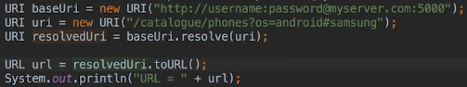  
* So basically when you want to access a webpage on the myserver.com host, you’ll combine the base URI with the Relative URI for the webpage or API or servers you want to access using the URI resolve() method.

**URL Connections and Input Stream Reader**  
* **In a real-world application you’d probably define the base URI as a constant**.  
* When working with many locations on the same host, it’s far better to use the base URI with Relative URIs.  
* The other thing you can also do is determine a Relative URI when you know the base URI and the Absolute URI, using:  
**URI** **relativize()**  
  
* That’s enough about working with URIs.  
* Let’s now move on to how to access a location on the Internet.  
* **Earlier I said that you use a URI until you actually want to access a resource and you then convert it to a URL**.  
=> **When working with web locations, you’ll mainly use URIs to build absolute URIs from relative ones**.  
* **For our simple examples, we’re going to use a URL right away, since we won’t be doing queries or building URIs based on user input**.  
* There are a few ways to read a webpage using Java.  
* example.org is a very simple example of a webpage and it’s actually setup by **IANA = Internet Assigned Numbers Authority**.  
  
* **There are versions of the URL constructor that accept a protocol / host / port / file, and other information but when reading webpages, an API or a service on the Internet, you usually just have to provide an HTTP web address and include any required parameters that form part of the URL**.  
* **Since all URLs are also URIs, you can convert the URL to a URI and call the methods that return the components of a URI**.

**URL toURI()**  
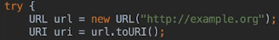  
* Now let’s try reading directly from the URL using an InputStreamReader.  
**BufferedReader**  
**InputStreamReader**  
**URL openStream() => opens a connections to the URL and underneath the covers it’s going to be doing all the Low Level stuff like creating a socket. The method returns an InputStream and we can read from it. Think of this as a convenience method that’s actually performing 2 steps that you can do individually.**\* The 2 steps: **Open a connection to a URL, then use the URL openConnection() method and that returns a URLConnection. Then you can get an InputStream from the URLConnection.**  
**BufferedReader** **close()**  
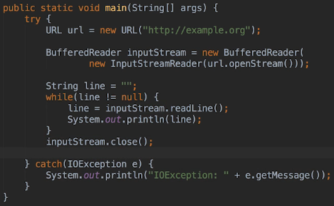  
* This gives us all the HTML:  
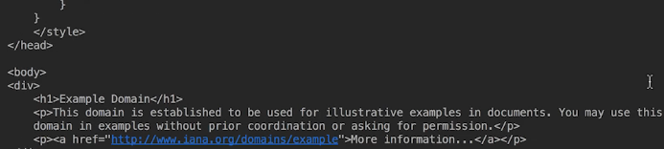  
* When you’re using your browser, it’s reading the HTML data or the file that’s returned that we can see in the console output. So the browser is rendering that based on that input. So it’s reading the file and rendering the style information, metadata and other information. In other words, it’s building a more user friendly view of what we can see in the console output.  
* When we’re reading a webpage pragmatically as we’ve done here, we’re just getting the raw HTML. So your application would then need to parse the HTML and pick out specific tags or other information depending on what you’re trying to achieve.  
* **This is 1 way to read a webpage**.  
* **The second way is to use the URLConnection class**.  
**URLConnection**  
**URL** **openConnection()**  
**URLConnection** **connect()**  
* Why do we have to call openConnection() and then the connect() method?  
=> That’s because the openConnection() call doesn’t connect to the URL. It returns an **OpenConnection** instance and you can use the instance then to configure the connection.  
=> You can say whether you want to READ or WRITE to the connection, whether CACHING will be used if that’s available for the protocol you’re using, and so on.

* **So it gives you a chance to send any configuration settings that will ultimately influence how the connection is made**.  
* By default, you can only read from a connection.  
=> If you want to write to a connection, you have to call the   
**URLConnection** **setDoOutput()** before you can call the connect method.  
* Trying to set values on the connection though, will result in an error.  
=> **Once you’ve actually called the connect() method, once you try to set values on the connection after that call, it will result in an error**.  
=> **Make sure you do any configuration after openConnection() but before connect().**  
* When using the URLConnection class, the URL you’re connecting to, doesn’t have to be a webpage or a web location and you don’t have to be using the HTTP scheme.  
* But many other methods in the class are only applicable to HTTP connections.  
=> **You actually want to use a subclass of URLConnection when connecting to a web URL rather than using the URLConnection directly**.  
* But I think it’s good to know how to use a more generic class. So let’s actually read that webpage.  
**URLConnection** **getInputStream()**  
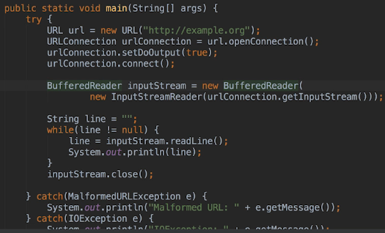  
* **Basically the code from BufferedReader on is very similar to when we read directly using an InputStreamReader, except for the URLConnection getInputStream() method call**.  
* If we run it, we get the same results, the HTML is correctly downloaded.  
* Next, let’s talk a bit more about the URLConnection and how you can do more than just read a webpage.

**HTTPUrlConnection**  
=> You can also get Header information from the webpage without having to read it in its entirety.  
**URLConnection** **getHeaderFields()**  
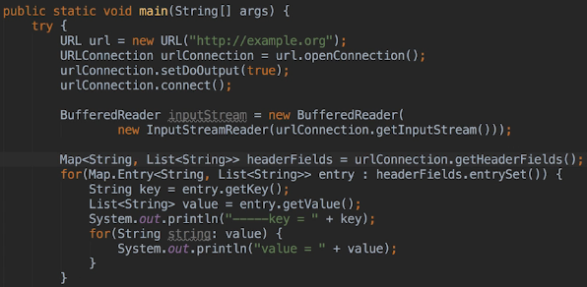  
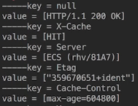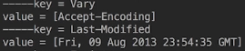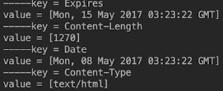  
* You can see there’s quite a few key values there.  
* You can use the:  
**URLConnection** **getHeaderField()** => to retrieve each of these values individually if you’re only interested in one or two.  
* There’s no forms on the page example.org that accept input so we can’t actually write there.  
* When you want to write to URL, you could use the URLConnection class but as I’ve mentioned the URLConnection is a generic connection class.  
=> When reading webpages or content created in feeds, essentially anything that can be reached over the internet using a URL, then you’ll want to use the HTTPUrlConnection class which is a subclass of URLConnection.  
* The reason that you want to use that is that the HTTPUrlConnection class contains support for HTTP specific features.  
* Let’s just go quickly over what happens when your browser requests a webpage or when you press the submit button on a form. I’m going to speak of this only at a very high level because I want to give you just enough information to help you understand how to use the HTTPUrlConnection class.

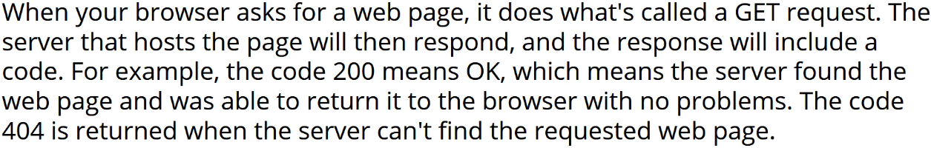

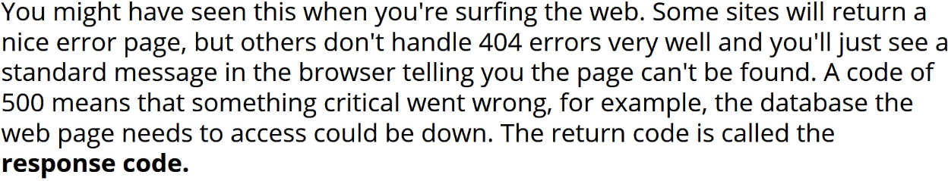

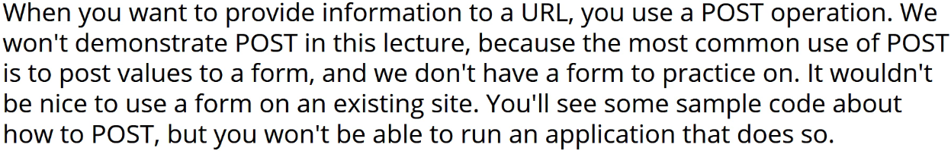  
* **500** => **something critically went wrong at the server side**.

**HttpURLConnection**  
* Out of interest - another type of URL that the method recognises is a JAR URL, so if you provide a URL for a jar file, the method will return a JarURLConnection instance and you do this when you want to read or write to a jar file and because the method recognises the HTTP protocol and returns the appropriate connection instance, it’s safe to cast the returned value to an HttpURLConnection object.  
* We want to read the webpage so we’re going to be using a GET connection.  
**HttpURLConnection setRequestMethod()** => parameter: “GET”, the default method is “GET” so you don’t actually have to call this method when you want to do a GET operation but to make it clear, we’ve done this here and **I recommend that you do add that even though it’s potentially an optional thing**.  
* In additional to GET and POST, you can also set the request method to: HEAD, OPTIONS, PUT, DELETE and TRACE.  
<https://www.w3.org/Protocols/rfc2616/rfc2616-sec9.html>   
* It’s important to note here that each HttpURLConnection instance can only be used to make 1 request. However, the underlying connection may actually persist across connection objects. Remember that Java is doing a lot of work under the covers here. When working with the High Level API, you’re dealing with Abstractions.  
=> So when you call the connect() method for the first time, Java has to create a socket and do all the handshaking etc. that we saw in earlier videos. But because we’re dealing with the High Level API, this is handled for us automatically. **And because the application you’re creating here might want to perform more requests**, **the underlying connection may persist, even if you close() the HttpURLConnection**.  
=> Having to create a socket for each request would be inefficient which is the reason that Java does that under the covers. So it keeps the connection open.  
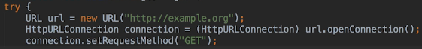  
* At this point you want to set some request properties. I’m not going to be able to go through everything you can set, but what you’re doing is setting the header fields which contain information about a request or a response.  
* As you saw earlier when getting a webpage, the header fields contain information about that webpage.  
<https://en.wikipedia.org/wiki/List_of_HTTP_header_fields>  
* In our case we’re setting the header fields for the request we’re making, which will provide the server with information about the request.  
* We’re going to set the user agent property as an example.  
**User-Agent** => this tells the server what browser or script that you’re using.  
**HttpURLConnection setRequestProperty()** => key, value  
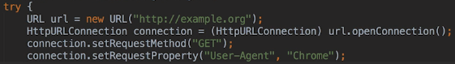  
* **Don’t worry if that’s not what you’re using by the way. It’s not the string that Chrome would use, and some webpages would reject the request, because hackers and spammers sometimes use questionable User-Agents**.  
* But the server hosting the example.org page doesn’t mind and if for some reason it does, you can just comment out this particular line of code.  
* The setRequestProperty() method is in the URLConnection parent class. If the property you’re setting can accept multiple values, you can only use one setRequestProperty() call and use commas to separate the values.  
* If you want to do a POST on the other hand at this point, you’d want to call **connection.setDoOutput(true) so you can actually write to the connection**.  
**HttpURLConnection getResponseCode()** => tells us whether we’ll be able to successfully read the page.  
* Just as with sockets, you can also set a Timeout value so if a website is down or the server is slow for some reason, your application won’t hang, waiting for a response.  
**HttpURLConnection setReadTimeout()**  
* Timeout of 10 - 15 seconds would probably be reasonable.  
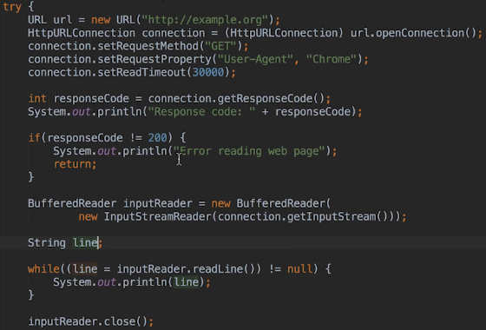  
* In the WHILE we’re both assigning the value of whatever we’ve read from the readLine() method and then we’re also checking to see whether that value is null.  
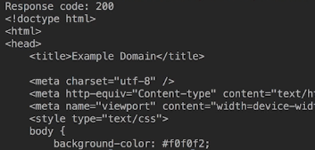  
* You might be thinking at this point - I didn’t call the connect() method so how is this working?  
=> **Some methods implicitly perform the connection step. When we call the getResponseCode() method, it performed the connection. In fact, the HttpURLConnection getInputStream() method also implicitly connects.** **So all the calls to connect have been unnecessary. Essentially, if an operation depends on being connected to work, it’ll actually perform the connection where necessary**.  
* **If you call connect() when a connection has already beeen established, the method doesn’t do anything so there’s no performance hit**.  
* In other words, explicitly calling connect() can make the code clearer for anyone reading it, but feel free to leave it out when the code calls another method that implicitly performs a connection.

**Alternatives to HttpURLConnection**  
* If we try to read a webpage that doesn’t exist:  
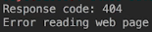  
* We can also call:  
**HttpURLConnection** **getResponseMessage()** => to get more information about the error.  
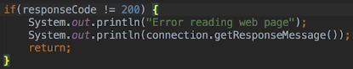  
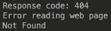  
* If you were doing a POST, you’d call the   
**HttpURLConnection** **getOutputStream()** => to get an **OutputStream** which you’d use to write to the connection. And you can also wrap the OutputStream in **DataOutputStream** if you want to.  
* Now let’s try **passing parameters as part of the URL** which is something you’ll often want to do.  
* We’re going to use the Flickr API service to fetch the most recently uploaded photos tagged with cats.  
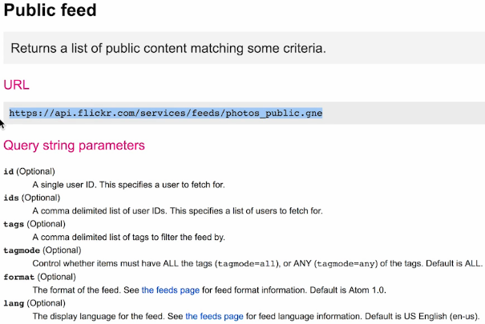  
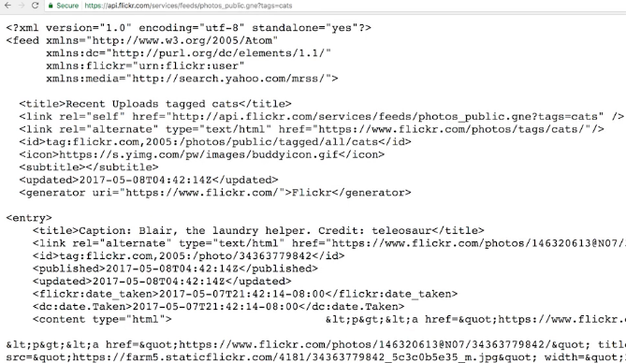  
=> We use the URL with ?tags=cats and we get an XML feed of carious photos.

* **When testing it’s always a good idea to try out the URL thata you’re working with using a browser before using it in the code**.  
* That way you can see for sure that you’ve got the URL correct and it’s functioning and it’s returning the right data, instead of just pasting it directly into your code and t hen not knowing if something doesn’t work whether it’s the URL at fault or something you’ve done wrong in your code.  
* If you were to read this URL into an application, you could display the photos or display a list of links or literally whatever else you want to do within your application.  
* If you were going to extract the information, you’d use an XML/RSS library to read the feed rather than writing code to parse it.  
* We just need to change the URL:  
  
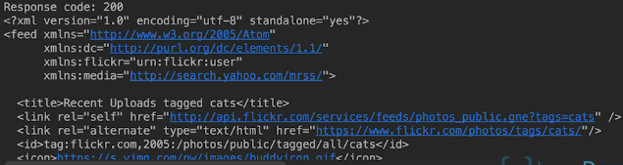  
* **Now we have HTTPS in the URL but we’re using the HttpURLConnection and not the HttpsURLConnection so what’s happening is that we’re not really truly using the HTTPS protocol**.  
* That’s becoming more common so you’d need to use the HttpsURLConnection instance to achieve that.  
* **The HttpsURLConnection class is NOT in the java.net package. It’s in the javax.net.ssl**.  
* Let’s look at how you go about writing to a connection. We’re not going to demonstrate this but the code will give you a pretty good idea of how it’s done.  
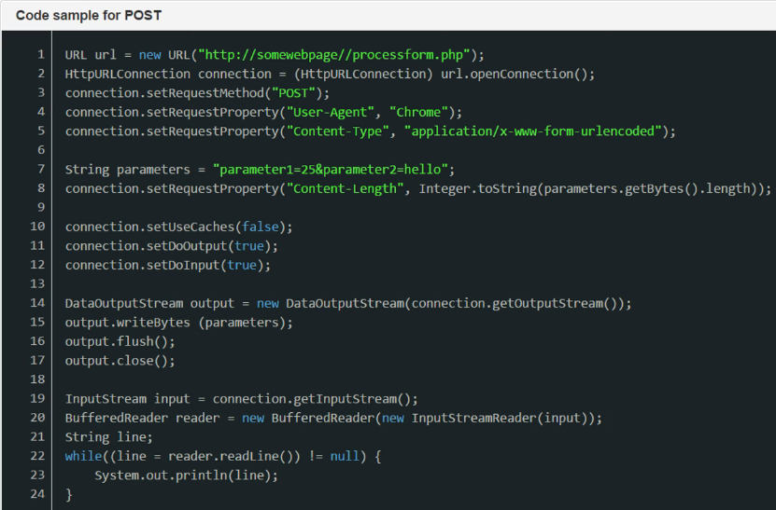  
* You could pass these parameters as part of the URL, but there are times when you want to pass them separately as we’re doing here. It gives you a few more options.  
* The parameters string is the part of t he URL that appears after a ? question mark.  
* In the case of the code on line 7 and 8, that’s a way to send multiple parameters. Firstly on line 8 we’re sending the parameters’ length, but if you look at the code on line 15, we’re writing out the bytes relating to the parameters there as well.  
* There are other ways to write this code. Depending on the server and the request, you might have to set more properties when you’re configuring the connection.  
* But this should give you an example of how you’d pass parameters separately from the URL.  
* In this particular case, the URL is a PHP script which could be the action that’s performed when a user submits a form, for example.  
* One lines 11 we set the output to be true, so that’s where the system would then ultimately know to write the code out, and then of course we’re using the output.writeBytes on line 15 to start writing some output and that’s wrapped around DataOutputStream because output.writeBytes is obviously using the DataOutputStream itself.

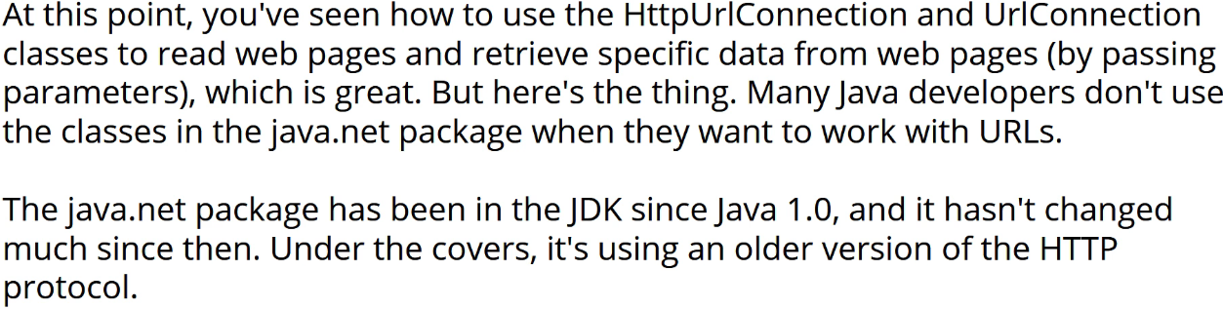

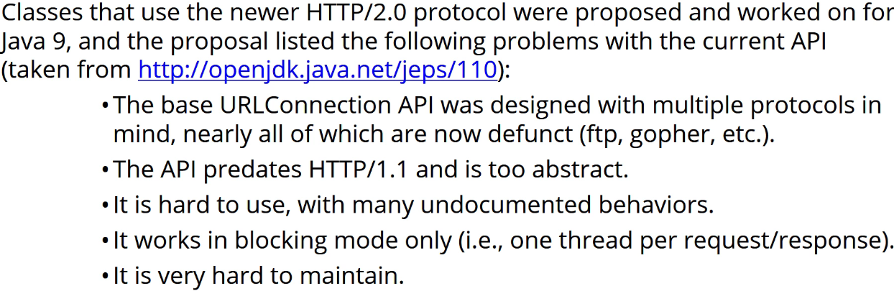

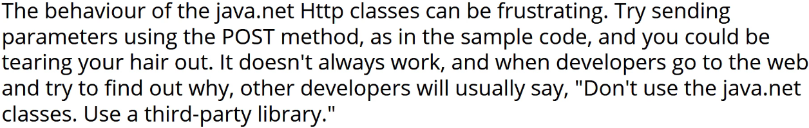

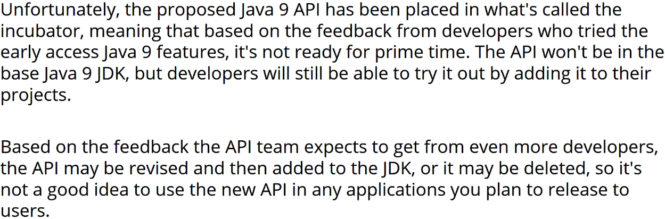

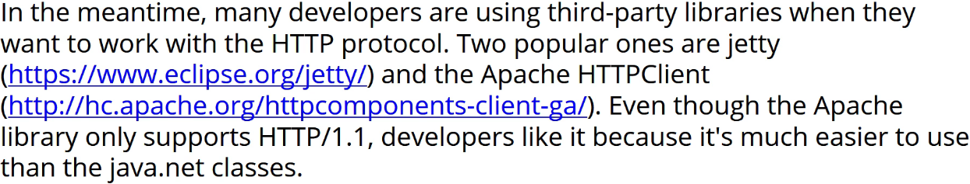  
**Jetty  
Apache**  
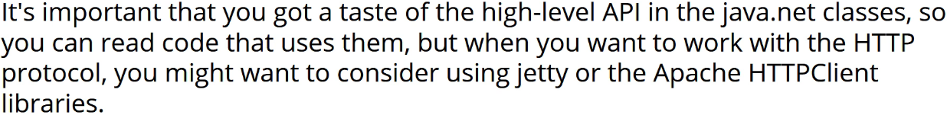  
* **To give you a taste of the Apache HTTPClient library, let’s use it to read our example site**.  
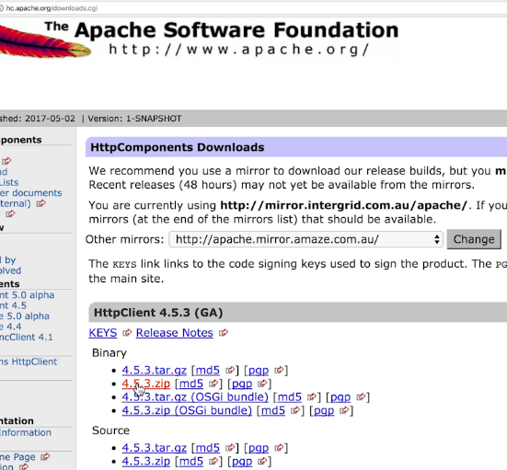  
**=> Download it the zip file => unzip it => File => Project Structure… => Libraries => + => Java => navigate to the folder => go to the lib folder => select all the jars that are part of that => Open => OK.**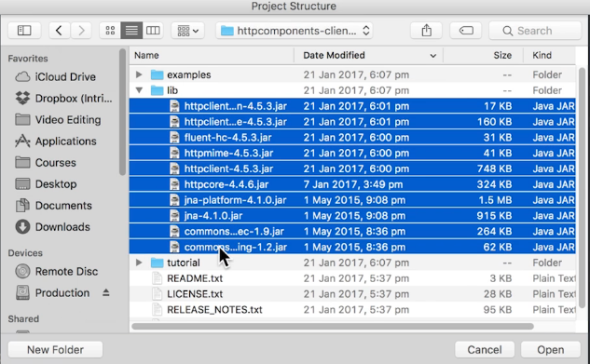

* Let’s create a new class called ApacheTest and let’s write an equivalent code to retrieve the webpage. Instead of using java.net, we’re going to be using the Apache HTTPClient.  
**CloseableHttpClient** =>   
**HttpClients.createDefault()** =>  
**HttpGet** =>   
**HttpGet addHeader()** =>  
**CloseableHttpResponse** =>  
**CloseableHttpClient** **execute()** =>  
**CloseableHttpResponse** **getStatusLine() . getStatusCode()** =>   
**CloseableHttpResponse getEntity() . getContent()** =>  
**CloseableHttpResponse close()** =>  
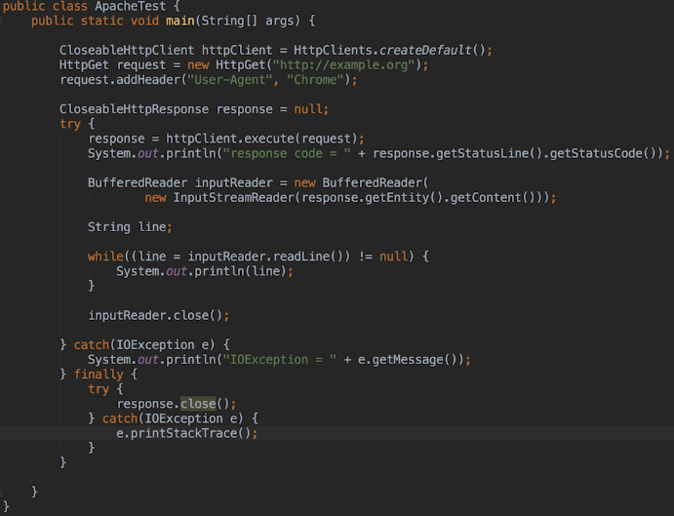  
* **You can see that it’s similar to what we had before, except that we’re creating this CloseableHttpClient instance and then we’re getting an HttpGet instance for the URL**.  
* **We configure the request object, not the HttpClient, so that’s a little bit different**.  
* **We’re then calling the CloseableHttpClient execute() method, that sends off the request**.  
* **When using the CloseableHttpResponse, it is highly recommended that you call the close() method in a FINALLY blcok as I’ve done here. The reason is that otherwise, system resources may not be released correctly**.  
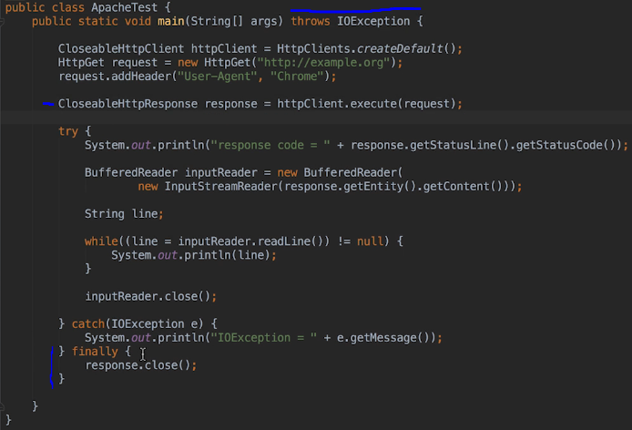  
* The other way I could’ve done this is to use the throws IOException and throw the IOException from the method instead of trying to catch that in the FINALLY block. If you don’t want to handle the extra call outside of the TRY as I did there, makes the FINALLY look a little bit more tidy.  
* But in any event, once we’ve got the response, we get the response code by calling the getStatusLine and then from that getting the status code. The rest of the code was pretty much the same except for the response.getEntity().getContent().  
* There are other ways of handling the content but we’re doing it this way because it’s very similar to how we handle the response when using the java.net HttpURLConnection class.

**Resources**  
URIs, URLs, and URNs: Clarification  
<https://www.w3.org/TR/uri-clarification/>   
Uniform Resource Identifier  
<https://en.wikipedia.org/wiki/Uniform_Resource_Identifier>   
Example Domain  
<http://example.org/>   
Method Definitions  
<https://www.w3.org/Protocols/rfc2616/rfc2616-sec9.html>   
List of HTTP header fields  
<https://en.wikipedia.org/wiki/List_of_HTTP_header_fields>   
Public feed  
<https://www.flickr.com/services/feeds/docs/photos_public/>   
Feed Url  
<https://api.flickr.com/services/feeds/photos_public.gne>   
JEP 110: HTTP/2 Client (incubator)  
<http://openjdk.java.net/jeps/110>   
Jetty  
<https://www.eclipse.org/jetty/>   
HttpClient Overview  
<http://hc.apache.org/httpcomponents-client-ga/>   
HttpComponents Downloads  
<http://hc.apache.org/downloads.cgi>